**[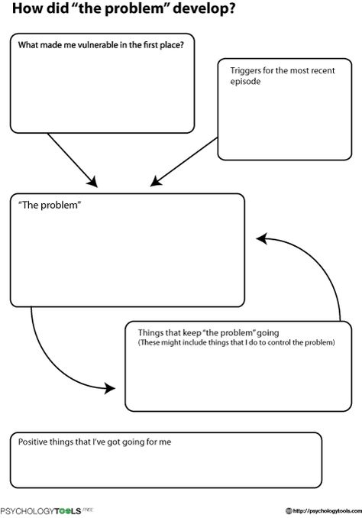](https://psychologytools.com/friendly-formulation.html)**