Positive Behaviour Support Plan

[For support in completing this please refer to the PBS Plan guidance document]
Date of initial plan: | Last review of plan: | Next review date:

This plan was created & agreed by:
Name | Role | Contact Details

PART A: BACKGROUND

- Who / Contact Details  INSERT PHOTO | Name:  NHS Number:  Date of Birth:  Address:  Telephone:
This plan should be implemented alongside a risk management plan. The two plans will proactively and reactively manage risk and support the reduction of restrictions. Restrictions include any intervention (environmental, physical, relational, psychological or pharmacological) that prevent a person in your care from pursuing free action. This plan should be developed with support from a clinician with behavioural expertise following an assessment and functional analysis of the problem behaviour. All staff implementing this plan should be supported via appropriate levels of training and supervision.

Consent to Intervention

- Intervention requiring test of mental capacity

Date
Discussion

Outcome: | The above named person has / does not have* Capacity in relation to decision  (*delete as appropriate)
Does this decision require a best interest decision? | Y/N

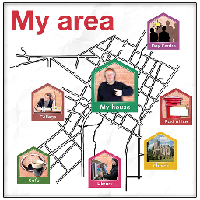
- Where and When the plan is to be used

- Background information
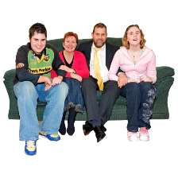

- Likes and Dislikes

- Physical Health

- Aims of PBS plan | Immediate Goals  Long Term Goals

PART B: ASSESSMENT OF BEHAVIOUR

- When does the behaviour happen? | Activities:  Places:  Other people (staff/service users/visitors):  Days or times of day:

- What is the behaviour and why do we think the behaviour happens?  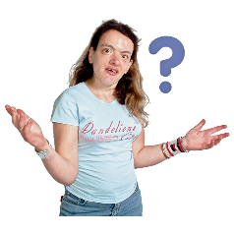 | Description of behaviour that challenges | Slow Triggers | Fast triggers | Function of the behaviour that challenges | Consequences/ History

- Reducing restrictions | What boundaries are currently in place to support the individual and to keep them safe?  Can we reduce these?  What strategies are in place to monitor, evaluate and reduce boundaries for this person?

PART C: Positive Behavioural Support
- Reinforcing the positive / Active Support | Person current strengths and skills –  What life skills can we offer and teach that will help the person cope with their challenging behaviour?  How can we promote active support?  How can we implement the PERMA model to ensure happiness and wellbeing for the individual?  Consider what the service user currently has in their life and what could be done to improve in these areas:  Positive Emotion –  Engagement –  Relationships –  Meaning –  Accomplishment –  **-Martin E. P. Seligman (2012). Flourish (A Visionary New Understanding of Happiness and Well-Being) . USA: Atria Books. 368.  https://www.youtube.com/watch?v=OWavCPydQ5k

- Environment | How can the individual’s environment be improved? Refer to the 12 Characteristics of the capable environment.  (Mcgill, et al 2020)

Traffic Light System

- Primary Preventative  Strategies  (Green Plan) | Indicators of baseline behaviour:  Positive Interactions and how to communicate  Active Support/Skills Teaching  Activities and Routines  Maintaining Triggers  Other Strategies

- Secondary Preventative Strategies  (Amber Plan/Early Warning Signs) | Early Indicators of behaviours escalating  Secondary strategies during Escalation / How should staff respond to this?

- Reactive Strategies  (Red Plan) | Non Physical Strategies reactive strategies  What PRN medication can be used [if appropriate]?  Restrictive physical interventions/ What reactive strategies can be used as a last resort?  Breakaway and self-protective physical interventions/  Planned restrictive physical interventions  NOTE: If restrictive interventions are frequently used the positive behaviour support plan should be reviewed.

- Post Incident Support  (Blue Plan) | How to tell the incident is over  How to support the individual  How to support others involved post incident and who do we need to inform (De-brief)?  What has been learned from the incident?

PBS Plan Grab Sheet
Name:
Primary Strategies  (What to do to prevent the behaviour happening) | Secondary Strategies  (What to do when the individual is showing warning signs) | Reactive Strategies  (What to do when the individual in crisis)
How does the individual present at their baseline (on a normal day to day):  What do to keep the individual happy and settled  Communication/Interaction:  Structure and Routine:  Sensory Needs:  Environment Needs:  Activities and other Strategies  What new skills to focus on | Warning signs:  How to support the individual when they are displaying early warning signs:  Communication/Interaction:  Environmental Management:  Distraction/Redirection:  What strategies can the individual utilise when they are displaying early warning signs?  PRN Medication [if required] | When the individual is in crisis they may:  How to support the individual when they are in crisis:  Environmental management:  Distraction/Redirection:  What strategies can the individual use when they are in crisis?  PRN Medication [if required]
Post Incident Support | How to support the individual  How to support others

19. Quality checklist | - Does the plan clearly indicate how restrictions placed on the individual are being monitored and evaluated?  Yes [ ] No [ ]  2. Is the plan reviewed with the patient and where appropriate family/carers to ensure it are working?  Yes [ ] No [ ]  3. Are records being kept up to date that enables you to see if the plan is working and restrictions are being reduced safely over time?  Yes [ ] No[ ]  4. If the plan is not helping or the person is facing increased restrictions is this being proactively raised with senior professionals involved in the person’s care?  Yes [ ] No[ ]  5. Are there any safeguarding concerns that need to be raised regarding this plan?  Yes [ ] No [ ]

Service User Review
Are you happy with plan?
Do you feel the plan is working? | 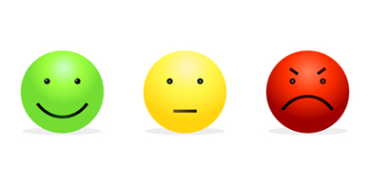
How can we make this better?
Do you agree this PBS plan? | 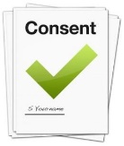  Yes No

PLAN EVALUTION & REVIEW
Plan Evaluation & Review
REVIEW 1  To be completed with 2 weeks of the plan being implemented | Completed By: |  |  |  | Date:
Number of incidents since last review?
Has the goals of the plan been achieved? Have new goals been set? |  | YES | NO | Details here:
Has the individual learnt any new skills? |  | YES | NO | Details here:
Has frequency of behaviours decreased? |  | YES | NO | Details here:
Has severity of behaviours decreased? |  | YES | NO | Details here:
Has duration of behaviours decreased? |  | YES | NO | Details here:
Is there a full record of each incident and the interventions used? |  | YES | NO | Details here:
Were interventions used effective? |  | YES | NO | Details here:
Have there been any changes in behaviours? |  | YES | NO | Details here:
Do the individual support team demonstrate awareness of the plan? |  | YES | NO | Details here:
Does the staff skill set match the needs of the individual? |  | YES | NO | Details here:
Is there evidence of a reduction in restrictions? |  | YES | NO | Details here:
Have all reasonable measures been put in place to safeguard the well-being of the person and other people? |  | YES | NO | Details here:
If you have answered ‘No’ to any of the above questions please escalate your concern to a senior professional/MDT.
Are changes to this plan or the risk management plan needed? If YES please state: |  | YES | NO | Details here:
Responsible Person: |  |  |  | Date:

PBS plans should be reviewed whenever the needs of the service user change or reviewed at least every 6 months. Please use above from to complete this as a MDT.

Service User PBS Grab Sheet
How am I feeling | What am I doing? | What can I do to help me? | What can other people do to help?

