Who should use this template?
Authors who want to provide content on a mental health topic to help young people/adults/people with learning disabilities, or their families/parents/carers should use this template.
This custom topic template should be used if the headings in the Structured Topic Template - 1) Information 2) Coping with 3) Finding help, and 4) Getting more help - are not appropriate for your content. If you have not looked at the Structured Topic Template we ask that you do so before continuing to fill out this template.

Before you use this Template
We recommend that you take a look at the topic content already on the Portal. The content contributors page also provides lots of support for creating content.

How to fill out this Template
Complete the below template along with the Front sheet.

Structuring your content
The template is split into sections to help structure your content.
We have provided 4 types of content: 1) Tabs, 2) Pop-up boxes, 3) Links, and 4) FAQ’s

Using images, audio and video
Adding media to your content is important in providing a user experience that draws your audience to the content. Media can be from any source but should be royalty free. See the section Guidance on images, audio and video content for further information and help.

Referencing
It is important that when we use information, images, audio, or video from other sources, that we reference these. So, if content from other places is provided, please add these references as well as the actual content. References should include the website link, author/organisation, and date where applicable.

NSCHT Portal Custom Topic Content
Content Information
Content Title
 | Content Author(s) & Role
 | Do you wish to be acknowledged as the Author on the Portal
 | Yes ☐ |  |  |  |  |  | No ☐
 | Service Applicable To: |  |  |  |  |  |  | Target Audience:
 | CYP | Adult |  |  |  | LD |  | Young people / Adults / People with LD | Family / Parent / Carer
 | ☐ | ☐ |  |  |  | ☐ |  | ☐ | ☐
 | Clinical Content?
 | Yes |  |  |  | No
 | ☐ |  |  |  | ☐

Content Governance
To ensure the content published on the Wellbeing Portal is credible, reliable and of high quality, please ensure the following areas are checked:
Checked | Author | Reviewers
Content tile? | ☐ | ☐
Correctly labelled if containing clinical content? | ☐ | ☐
Clinically/factually correct? | ☐ | ☐
Links work and go to right place? | ☐ | ☐
Spelling/Grammar/Punctuation? | ☐ | ☐

Date
Checked By (Colleague / Team / Service):
Directorate Sign-off:
Support - If you require any further clarification on the processes
Portal Topics PortalTopics@combined.nhs.uk

Date
(Digital Team to Complete)
Approved By Clinical Effectiveness Group:
(If clinical content)
Agreed By Quality Committee:
(If clinical content)
Published:
To be Reviewed:

A Quick Guide to this Template
= indicates where you need to add text
📷🔉📼 = indicates where you can add images, audio, and videos

Content Title
Make this a brief as possible (e.g. Alcohol).
Please provide the title for your content.

Topic Tile
The topic tile provides a link to the page with your topic content. Topic tiles are displayed as a word cloud. The word cloud will be autogenerated for you, based upon your topic title. You will have the opportunity to review the word cloud before it is publicly published on the Portal to ensure that all the words used are appropriate.

Structure & Format
To help structure your content, we encourage you to group your content into sections. The number of sections is up to you as the author; however we would recommend between 2-4.
There are four different formats that you can use for each section: 1) Tabs, 2) Pop-up boxes, 3) Links, and 4) FAQ’s.

Format | Heading | When to use
Tabs | Content is divided into tabs, displayed horizontally across the page; when a tab’s title is clicked, the tab's contents are shown | If you have lots of text, to help break it down and make it easier to digest for the user.
Pop-up boxes | 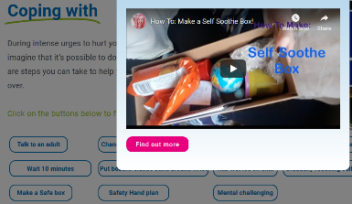  Content is divided into multiple boxes that pop-up on screen when the button displaying the title of the pop-up box is clicked. | If you have lots of multimedia, that would be too busy all together on a page.
Logos | Links to other webpages are displayed visually as logos. Links can be grouped together and arranged under different tabs. | If a lot of your content involves signposting. The portal developers can help create the logo or image based on the link you provide.
FAQs | When a question is clicked on, the box is expanded to reveal the answer in an accordion style. | If you want to provide the user the opportunity to delve into further detail on certain subjects, without making the main content page too busy.

- A template for each type of format is provided below, and provides further explanation of each type of format. You can use each format type multiple times, or not at all. Copy and paste, and reorder, the templates for each format as required for your content.
Section | Section Name | Format
Section 1
Section 2
Section 3
Section 4

Section 1
For the first section, provide the name, format, image, and content to be included.

Section 1 – Name, Format and Image
- Make the section name as brief as possible
- For images provide relevant references, click here for further guidance
- Using the table above, please provide the chosen format for your content.

Section 1 Name | Section 1 Format  (Tabs, Pop-boxes, Logos, or FAQs) | Section 1 Image  Include references
 |  | 📷

Section 1 - Content
Depending upon the format you have selected the sub-section heading may refer: to the tab or button heading; the question you will be answering; or what the logos include/what you will be providing a link to. The text heading may refer to: the tab or pop-up content; the answer to the question; or text to accompany the logos/links.
- Media can be from any source but should be royalty free
- Remember to provide references if including information, images, audio, or video from other sources
- Click here for further guidance

- Complete as many or as few rows as required

Sub-section heading | Text  Place references to any images, audio, and video where you would like them to appear | Images, audio, & video
 |  | 📷🔉📼

Section 2
For the second section, provide the name, format, image, and content to be included.

Section 2 – Name, Format and Image
- Make the section name as brief as possible
- For images provide relevant references, click here for further guidance
Using the table above, please provide the chosen format for your content.

Section 2 Name | Section 2 Format  (Tabs, Pop-boxes, Logos, or FAQs) | Section 2 Image  Include references
 |  | 📷

Section 2 - Content
Depending upon the format you have selected the sub-section heading may refer: to the tab or button heading; the question you will be answering; or what the logos include/what you will be providing a link to. The text heading may refer to: the tab or pop-up content; the answer to the question; or text to accompany the logos/links.
- Media can be from any source but should be royalty free
- Remember to provide references if including information, images, audio, or video from other sources
- Click here for further guidance

- Complete as many or as few rows as required

Sub-section heading | Text  Place references to any images, audio, and video where you would like them to appear | Images, audio, & video
 |  | 📷🔉📼

Section 3
For the third section, provide the name, format, image, and content to be included.

Section 3 – Name, Format and Image
- Make the section name as brief as possible
- For images provide relevant sources, click here for further guidance
Using the table above, please provide the chosen format for your content.

Section 3 Name | Section 3 Format  (Tabs, Pop-boxes, Logos, or FAQs) | Section 3 Image  Include references
 |  | 📷

Section 3 - Content
Depending upon the format you have selected the sub-section heading may refer: to the tab or button heading; the question you will be answering; or what the logos include/what you will be providing a link to. The text heading may refer to: the tab or pop-up content; the answer to the question; or text to accompany the logos/links.
- Media can be from any source but should be royalty free
- Remember to provide references if including information, images, audio, or video from other sources
- Click here for further guidance

- Complete as many or as few rows as required

Sub-section heading | Text  Place references to any images, audio, and video where you would like them to appear | Images, audio, & video
 |  | 📷🔉📼

Section 4
For the fourth section, provide the name, format, image, and content to be included.

Section 4 – Name, Format and Image
- Make the section name as brief as possible
- For images provide relevant sources, click here for further guidance
Using the table above, please provide the chosen format for your content.

Section 4 Name | Section 4 Format  (Tabs, Pop-boxes, Logos, or FAQs) | Section 4 Image  Include references
 |  | 📷

Section 4 - Content
Depending upon the format you have selected the sub-section heading may refer: to the tab or button heading; the question you will be answering; or what the logos include/what you will be providing a link to. The text heading may refer to: the tab or pop-up content; the answer to the question; or text to accompany the logos/links.
- Media can be from any source but should be royalty free
- Remember to provide references if including information, images, audio, or video from other sources
- Click here for further guidance

- Complete as many or as few rows as required

Sub-section heading | Text  Place references to any images, audio, and video where you would like them to appear | Images, audio, & video
 |  | 📷🔉📼

Guidance on images, audio and video content

Introduction and overview
It is important that the content on the portal comes from experienced professionals, both in mental health services and the community. By providing the information using the advice and format shown in this document, this will allow the portal developers to implement the content much faster.

- The existing content on the portal is a great source of ideas on how content can be presented

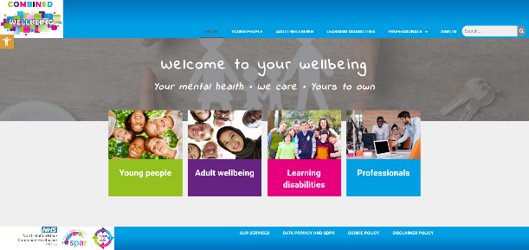
Several pages have already been implemented in the Engagement portal and viewing the site, whilst reading this guide, may be helpful.
- https://combinedwellbeing.org.uk/
- The existing page on self harm for young people is an example of a completed page that uses media well -https://combinedwellbeing.org.uk/topic/self-harm/

Use of media (Photos, graphics, video, audio)
Use of media can be a great way to replace lots of text, with an audio file or a video. Likewise, use of photos with content can help break up the text and make it more engaging.

How to add files
- Go to Insert > Object
- Select Create from File
- Select Browse and choose the file you want to use
- Select Insert
- Choose Display as icon to embed
- Select OK
NB: Add references under each inserted file, where applicable.

Referencing
It is important that when we use information, images, audio, or video from other sources, that we reference these. So, if content from other places is provided, please add these references as well as the actual content. References should include the website link, author/organisation, and date where applicable.

All media types
- Media can be from any source, but should be royalty free
- If media is available online, a link to the media is enough, otherwise, please provide the media as a separate file, and provide the file name in this template where requested, so portal developers know where to add them
- Media could be sourced from the community using volunteers and simple use of mobile phones etc (as long as the quality is acceptable)
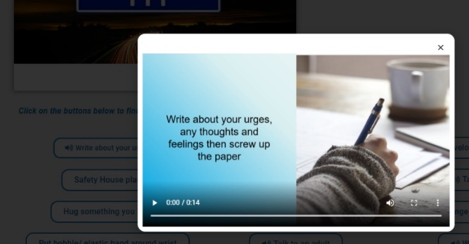

Audio
Use of Audio clips can be a good way to replace text and can be more engaging than reading. The existing portal has some good examples where “soundbites” have been used associated with pop-up buttons – scroll down to the “coping with” section of the “Self harm” page for an example and click “Write about your urges”

Photos/graphics
Where requested in the template above, a suitable photo or link to an online photo should be provided. Whilst the portal developers can attempt to source photos, it is much better to have these provided by an experienced professional in the content
- Some example websites with royalty free images and photos are:
  - https://www.pexels.com/
  - https://pixabay.com/
  - https://blog.snappa.com/free-stock-photos/ - Not a photo site itself, but does list 21 sites
- Photos and graphics should avoid being negative where possible

Logos
Using a logo can be a more engaging way to display the name of a service, and can help to grab the attention of the audience. If a logo is available online, a link to the logo is enough, otherwise, please add the logo as a file. Please ensure you have permission to use any logos.

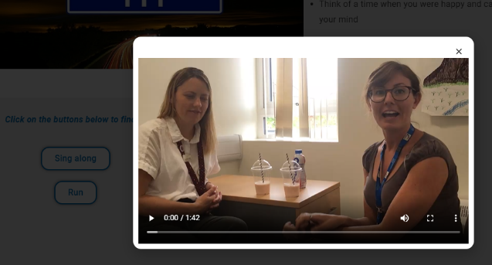
Video
Videos are a great way to engage your audience, rather than walls of text. Videos can be simply added to a page, or also put into a tab or pop up box. The existing portal has some good examples where videos have been used associated with pop-up buttons - scroll down to the “coping with” section of the “Feeling Angry” page for an example and click “Relaxation techniques”
- Videos should be no longer than 5 minutes

