Who should use this template?
Only authors who want to provide information about factors that influence mental health, but that aren’t mental health issues per se should use this template.

Before you use this Template
We recommend that you take a look at the Other Concerns and Worries content already on the Portal. The content contributors page also provides lots of support for creating content.

How to fill out this Template
Complete the below template along with the Front sheet.

Structuring your content
There is a choice of two templates depending upon the length of your content.
- Your content might be no more than suggesting a link to another organization for support or a couple of lines of advice. If so, please use Option 1 - Short Template.
- Alternatively you might have more substantial content, which you may want to break up into sections and include media. If so, use “Option 2 - Long Template”. We have suggested some section names: 1) Key Information, 2) Additional content, 3) Useful links, and 4) Services. These are a starting point; you may want to consider altering these names to better suit your content. There is no obligation to use all of the sections.

Using images, audio and video
Adding media to your content is important in providing a user experience that draws your audience to the content. Media can be from any source but should be royalty free. See the section Guidance on images, audio and video content for further information and help.

Referencing
It is important that when we use information, images, audio, or video from other sources, that we reference these. So, if content from other places is provided, please add these references as well as the actual content. References should include the website link, author/organisation, and date where applicable.

NSCHT Portal Other Concerns and Worries Content
Content Information
Content Title
 | Content Author(s) & Role
 | Do you wish to be acknowledged as the Author on the Portal
 | Yes ☐ |  |  |  |  |  | No ☐
 | Service Applicable To: |  |  |  |  |  |  | Target Audience:
 | CYP | Adult |  |  |  | LD |  | Young people / Adults / People with LD | Family / Parent / Carer
 | ☐ | ☐ |  |  |  | ☐ |  | ☐ | ☐
 | Clinical Content?
 | Yes |  |  |  | No
 | ☐ |  |  |  | ☐

Content Governance
To ensure the content published on the Wellbeing Portal is credible, reliable and of high quality, please ensure the following areas are checked:
Checked | Author | Reviewers
Correctly labelled if containing clinical content? | ☐ | ☐
Clinically/factually correct? | ☐ | ☐
Links work and go to right place? | ☐ | ☐
Spelling/Grammar/Punctuation? | ☐ | ☐

Date
Checked By (Colleague / Team / Service):
Directorate Sign-off:
Support - If you require any further clarification on the processes
Portal Topics PortalTopics@combined.nhs.uk

Date
(Digital Team to Complete)
Approved By Clinical Effectiveness Group:
(If clinical content)
Agreed By Quality Committee:
(If clinical content)
Published:
To be Reviewed:

A Quick Guide to this Template
= indicates where you need to add text
📷🔉📼 = indicates where you can add images, audio, and videos

Option 1 - Short Template
This template is suitable for content that is just suggesting a link to another organization for support, or limited to no more than or a couple of lines of advice.

Other Concerns and Worries Title
This could be a question or a descriptive heading. Make this as brief as possible. E.g. Worries about sexually transmitted diseases or pregnancy
Other Concerns and Worries Title

Other Concerns and Worries Content
Content details

Option 2 - Long Template
This template is suitable for mores substantial content that might be in different sections and include pictures and/or other media.

Content Title and Image
Provide the title for your content and an accompanying image if you do not want to use the one provided here.
- Make the title as brief as possible. E.g. Worries about sexually transmitted diseases or pregnancy
- If relevant, provide references for your image. Click here for further guidance

Content Title | Optional  Accompanying Image (if default image not appropriate)  Include references
 | 📷

Structure
To help structure your content, this template is split into different sections. We advise that you start with the suggested heading of key information. If this heading does not work, you can adapt the wording to make it more suitable for your content. Additional content and useful links (contact details of services and/or partner & affiliates that are relevant to professionals) are potential headings that may also like to consider, but it is entirely your choice as the author. If you feel necessary, you can add an additional section(s). To create more than one addition section you can copy and paste Section 3 of the template.

Section | Suggested Heading
Section 1 | Key Information
Section 2 | Additional content
Section 3 | Useful links
Section 4 | Services

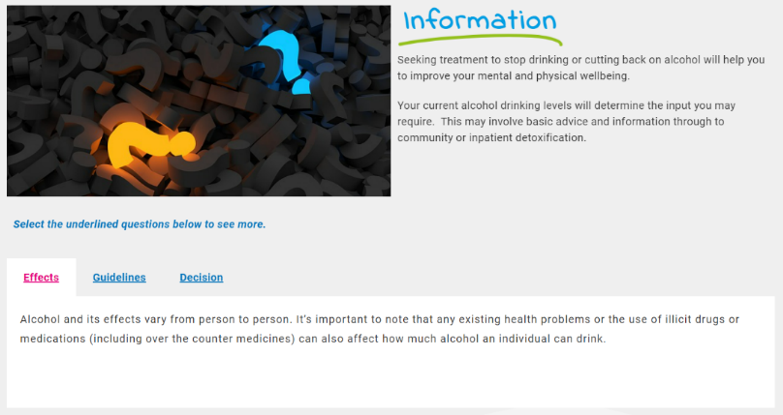
Section 1 – Key Information
We suggest ‘Key Information’ as the name for the first section. However, if this name does not work for your content you can provide a different name below.

Section 1 – Optional: If not using ‘Key Information’
- If you would like to use a different name for the first section, please provide it below
- If the default image shown not appropriate, you can provide a different image to be used. If relevant provide references, click here for further guidance.

Optional  Section 1 Name (If ‘Key Information’ not appropriate) | Optional  Section 1 Image (If default image not appropriate)  Include references
 | 📷

Section 1 - Content
- Break your text down into sub-sections with headings
- Media can be from any source but should be royalty free
- Remember to provide references if including information, images, audio, or video from other sources
- Click here for further guidance
- Complete as many or as few rows as required.

Sub-section heading | Text  Place references to any images, audio, and video where you would like them to appear | Images, audio, & video
 |  | 📷🔉📼

Section 2 – Additional content
We suggest ‘Additional content’ as the name for the second section. However, if this name does not work for your content you can provide a different name below.
Section 2 – Optional: If not using ‘Additional Content’
- If you would like to use a different name for the second section, please provide it below
- If the default image shown above is no longer appropriate, you can provide a different image to be used. If the default image shown not appropriate, you can provide a different image to be used. If relevant provide references, click here for further guidance.

Optional  Section 2 Name (If ‘Additional Content’ not appropriate) | Optional  Section 2 Image (If default image not appropriate)  Include references
 | 📷

Section 2 – Content
- Break your text down into sub-sections with headings
- Media can be from any source but should be royalty free
- Remember to provide references if including information, images, audio, or video from other sources
- Click here for further guidance

- Complete as many or as few rows as required.

Sub-section heading | Text  Place references to any images, audio, and video where you would like them to appear | Images, audio, & video
 |  | 📷🔉📼

Section 3 – Useful links
We suggest ‘Useful links’ as the name for the third section. This section might contain some of the following:
- Useful documents – Provide link(s) to the document(s), the portal developers will create the logo or image based on the document, or organisation providing the document
- Useful Apps and tools – Provide link(s) to the app(s) or tool(s), the portal developers will create the logo or image based on the app or tool. If this is a mobile app, provide links to versions on IOS and Android if both available
- Helpful Websites – Provide link(s) to the website(s), the portal developers will create the logo or image based on the website.

However, if ‘Useful links’ does not work for your content you can provide a different name below.

Section 3 – Optional: If not using ‘Useful links’
- If you would like to use a different name for the second section, please provide it below
- If the default image shown above is no longer appropriate, you can provide a different image to be used. If relevant provide references, click here for further guidance.

Optional  Section 3 Name (If ‘Useful links’ not appropriate) | Optional  Section 3 Image (If default image not appropriate)  Include references
 | 📷

Section 3 - Content
- Break your text down into sub-sections with headings
- Media can be from any source but should be royalty free
- Remember to provide references if including information, images, audio, or video from other sources
- Click here for further guidance
- If providing links, the portal developers can create a logo or image based on the link you provide

- Complete as many or as few rows as required.

Sub-section heading | Text  Place references to any images, audio, and video where you would like them to appear | Images, audio, & video
 |  | 📷🔉📼

Section 4 – Services
We suggest ‘Services’ as the heading for the fourth section. This section might contain some of the following:
- Local Services – Add link(s) below to the Local service website, the portal developers will create the logo or image based on the document, or organisation providing the service
- National Support Organisations – Add link(s) below to the National Organisation website, the portal developers will create the logo or image based on the document, or organisation providing the service
- Help lines – Add link(s) below to the Help line website, the portal developers will create the logo or image based on the document, or organisation providing the service

However, if ‘Services’ does not work for your content you can provide a different name below.
Section 4 – Optional: If not using ‘Services’
- If you would like to use a different name for the first section, please provide it below
- If the default image shown not appropriate, you can provide a different image to be used. If relevant provide references, click here for further guidance.

Optional  Section 4 Name (If ‘Useful links’ not appropriate) | Optional  Section 4 Image (If default image not appropriate)  Include references
 | 📷

Section 4 - Content
- Break your text down into sub-sections with headings
- Media can be from any source but should be royalty free
- Remember to provide references if including information, images, audio, or video from other sources
- Click here for further guidance
- If providing links, the portal developers can create a logo or image based on the link you provide

- Complete as many or as few rows as required.

Sub-section heading | Text  Place references to any images, audio, and video where you would like them to appear | Images, audio, & video
 |  | 📷🔉📼

Use of media (Photos, graphics, video, audio)

Introduction and overview
Use of media can be a great way to replace lots of text, with an audio file or a video, likewise, use of photos with content can help break up the text and make it more engaging.

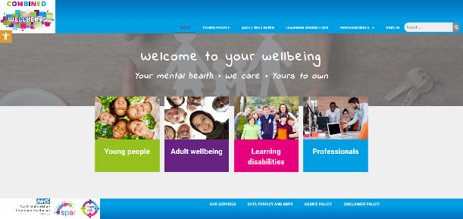
Several pages have already been implemented in the Engagement portal and viewing the site, whilst reading this guide, may be helpful.
- https://combinedwellbeing.org.uk/
- The existing page on self harm for young people is an example of a completed page that uses media well -https://combinedwellbeing.org.uk/topic/self-harm/

How to add files
- Go to Insert > Object
- Select Create from File
- Select Browse and choose the file you want to use
- Select Insert
- Choose Display as icon to embed
- Select OK
NB: Add references under each inserted file, where applicable.

Referencing
It is important that when we use information, images, audio, or video from other sources, that we reference these. So, if content from other places is provided, please add these references as well as the actual content. References should include the website link, author/organisation, and date where applicable.

All media types
- Media can be from any source, but should be royalty free
- If media is available online, a link to the media is enough, otherwise, please provide the media as a separate file, and provide the file name in this template where requested, so portal developers know where to add them
- Media could be sourced from the community using volunteers and simple use of mobile phones etc (as long as the quality is acceptable)
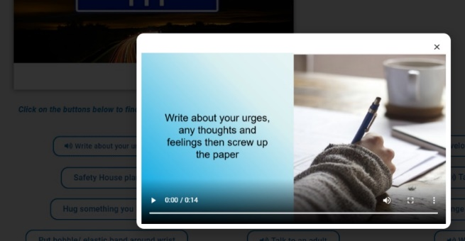

Audio
Use of Audio clips can be a good way to replace text and can be more engaging than reading. The existing portal has some good examples where “soundbites” have been used associated with pop-up buttons – scroll down to the “coping with” section of the “Self harm” page for an example and click “Write about your urges”

Photos/graphics
Where requested in the template above, a suitable photo or link to an online photo should be provided. Whilst the portal developers can attempt to source photos, it is much better to have these provided by an experienced professional in the content
- Some example websites with royalty free images and photos are:
  - https://www.pexels.com/
  - https://pixabay.com/
  - https://blog.snappa.com/free-stock-photos/ - Not a photo site itself, but does list 21 sites
- Photos and graphics should avoid being negative where possible

Logos
Using a logo can be a more engaging way to display the name of a service, and can help to grab the attention of the audience. If a logo is available online, a link to the logo is enough, otherwise, please add the logo as a file. Please ensure you have permission to use any logos.

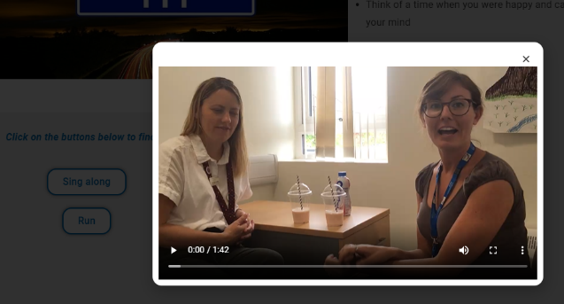
Video
Videos are a great way to engage your audience, rather than walls of text. Videos can be simply added to a page, or also put into a tab or pop up box. The existing portal has some good examples where videos have been used associated with pop-up buttons - scroll down to the “coping with” section of the “Feeling Angry” page for an example and click “Relaxation techniques”
- Videos should be no longer than 5 minutes

