Who should use this template?
Only authors who want to provide information to help other professionals should use this template.

Before you use this Template
We recommend that you take a look at the content for professionals already on the Portal. The content contributors page also provides lots of support for creating content.

How to fill out this Template
Complete the below template along with the Front sheet. On the Front sheet indicate if any content needs to be ‘Private’ so only those with sign in privileges can see this content (i.e. other professionals). For example, some phone numbers may not be intended for the public. Please specify on the template which content needs to be private.

Structuring your content
The template is split into sections to help structure your content. We have provided some suggested section names: 1) Information, 2) Additional content, and 3) Useful links.
Please do not feel limited by these names. These are a starting point, but it is entirely your choice as the author. You may want to consider altering the wording of these names to better suit your content. There is also no obligation to use all of the sections. At the end of the template you can also add an additional section.

Using images, audio and video
Adding media to your content is important in providing a user experience that draws your audience to the content. Media can be from any source but should be royalty free. See the section Guidance on images, audio and video content for further information and help.

Referencing
It is important that when we use information, images, audio, or video from other sources, that we reference these. So, if content from other places is provided, please add these references as well as the actual content. References should include the website link, author/organisation, and date where applicable.

NSCHT Portal Professional Content
Content Information
Content Title
 | Content Author(s) & Role
 | Do you wish to be acknowledged as the Author on the Portal
 | Yes ☐ |  |  |  |  |  | No ☐
 | Service Applicable To: |  |  |  |  |  |  | Target Audience:
 | CYP | Adult |  |  |  | LD |  | Young people / Adults / People with LD | Family / Parent / Carer
 | ☐ | ☐ |  |  |  | ☐ |  | ☐ | ☐
 | Clinical Content?
 | Yes |  |  |  | No
 | ☐ |  |  |  | ☐

Content Governance
To ensure the content published on the Wellbeing Portal is credible, reliable and of high quality, please ensure the following areas are checked:
Checked | Author | Reviewers
Content tile? | ☐ | ☐
Correctly labelled if containing clinical content? | ☐ | ☐
Clinically/factually correct? | ☐ | ☐
Links work and go to right place? | ☐ | ☐
Spelling/Grammar/Punctuation? | ☐ | ☐

Date
Checked By (Colleague / Team / Service):
Directorate Sign-off:
Support - If you require any further clarification on the processes
Portal Topics PortalTopics@combined.nhs.uk

Date
(Digital Team to Complete)
Approved By Clinical Effectiveness Group:
(If clinical content)
Agreed By Quality Committee:
(If clinical content)
Published:
To be Reviewed:

A Quick Guide to this Template
= indicates where you need to add text
📷🔉📼 = indicates where you can add images, audio, and videos

Aim
This is a brief statement about what your content will cover.
Please provide a brief statement concerning your aim to this content.

Content Title
Make this a brief as possible (e.g. Substance Misuse and Alcohol Services for Patients in Stoke-on-Trent).
Please provide the title for your content.

Structure
To help structure your content, this template is split into different sections. We advise that you start with the suggested heading of ‘Information’. If this heading does not work, you can adapt the wording to make it more suitable for your content. Additional content and useful links (contact details of services and/or partner & affiliates that are relevant to professionals) are potential headings that may also like to consider, but it is entirely your choice as the author. If you feel necessary, you can add an additional section(s). To create more than one addition section you can copy and paste Optional Additional Section of the template.

Section | Suggested Name
Section 1 | Information
Section 2 | Additional content
Section 3 | Useful links
Optional Additional Section

Section 1 – Information
We suggest ‘Information’ as the name for the first section. However, if this name does not work for your content you can provide a different name below.

Section 1 – Optional: If not using ‘Information’
- If you would like to use a different name for the first section, please give it below
- If the default image shown above is no longer appropriate, you can provide a different image to be used. If relevant provide references, click here for further guidance
Optional  Section 1 Name (If ‘Information’ not appropriate) | Optional  Section 1 Image (If default image not appropriate)  Include references
 | 📷

Section 1 – Content
- Break your text down into sub-sections with headings
- Media can be from any source but should be royalty free
- Remember to provide references if including information, images, audio, or video from other sources
- Click here for further guidance

- Complete as many or as few rows as required

Sub-section heading | Text  Place references to any images, audio, and video where you would like them to appear | Images, audio, & video
 |  | 📷🔉📼

Section 2 – Additional content
We suggest ‘Additional content’ as the name for the second section. However, if this name does not work for your content you can provide a different name below.

Section 2 – Optional: If not using ‘Additional Content’
- If you would like to use a different name for the second section, please give it below
- If the default image shown above is no longer appropriate, you can provide a different image to be used. If relevant provide references, click here for further guidance

Optional  Section 2 Name (If ‘Additional Content’ not appropriate) | Optional  Section 2 Image (If default image not appropriate)  Include references
 | 📷

Section 2 - Content
- Break your text down into sub-sections with headings
- Media can be from any source but should be royalty free
- Remember to provide references if including information, images, audio, or video from other sources
- Click here for further guidance

- Complete as many or as few rows as required

Sub-section heading | Text  Place references to any images, audio, and video where you would like them to appear | Images, audio, & video
 |  | 📷🔉📼

Section 3 – Useful links
We suggest ‘Useful links’ as the heading for the third section. However, if this name does not work for your content you can provide a different name below.

Section 3 – Optional: If not using ‘Useful links’
- If you would like to use a different name for the third section, please give it below
- If the default image shown above is no longer appropriate, you can provide a different image to be used. If relevant provide references, click here for further guidance

Optional  Section 3 Name (If ‘Useful links’ not appropriate) | Optional  Section 3 Image (If default image not appropriate)  Include references
 | 📷

Section 3 - Content details
- Break your text down into sub-sections with headings
- Media can be from any source but should be royalty free
- Remember to provide references if including information, images, audio, or video from other sources
- Click here for further guidance

- Complete as many or as few rows as required

Sub-section heading | Text  Place references to any images, audio, and video where you would like them to appear | Images, audio, & video
 |  | 📷🔉📼

Optional Additional Section
If you feel necessary, you can add an additional section.

Additional section - Name and image
- Provide the name and image for your additional section.
- Provide references for any images, click here for further guidance

Additional Section Name | Additional Section Image  Include references
 | 📷

Additional section - Content
- Break your text down into sub-sections with headings
- Media can be from any source but should be royalty free
- Remember to provide references if including information, images, audio, or video from other sources
- Click here for further guidance

- Complete as many or as few rows as required

Sub-section heading | Text  Place references to any images, audio, and video where you would like them to appear | Images, audio, & video
 |  | 📷🔉📼

Guidance on images, audio and video content
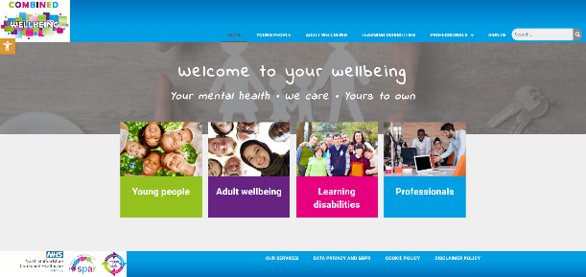
Several pages have already been implemented in the Engagement portal and viewing the site, whilst reading this guide, may be helpful.
- https://combinedwellbeing.org.uk/
- The existing page on self harm for young people is an example of a completed page that uses media well -https://combinedwellbeing.org.uk/topic/self-harm/

Use of media (Photos, graphics, video, audio)
Use of media can be a great way to replace lots of text, with an audio file or a video, likewise, use of photos with content can help break up the text and make it more engaging.

How to add files
- Go to Insert > Object
- Select Create from File
- Select Browse and choose the file you want to use
- Select Insert
- Choose Display as icon to embed
- Select OK
NB: Add references under each inserted file, where applicable.

Referencing
It is important that when we use information, images, audio, or video from other sources, that we reference these. So, if content from other places is provided, please add these references as well as the actual content. References should include the website link, author/organisation, and date where applicable.

All media types
- Media can be from any source, but should be royalty free
- If media is available online, a link to the media is enough, otherwise, please provide the media as a separate file, and provide the file name in this template where requested, so portal developers know where to add them
- Media could be sourced from the community using volunteers and simple use of mobile phones etc (as long as the quality is acceptable)
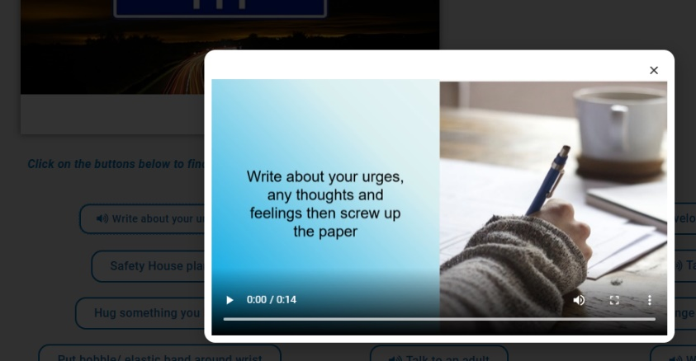

Audio
Use of Audio clips can be a good way to replace text and can be more engaging than reading. The existing portal has some good examples where “soundbites” have been used associated with pop-up buttons – scroll down to the “coping with” section of the “Self harm” page for an example and click “Write about your urges”

Photos/graphics
Where requested in the template above, a suitable photo or link to an online photo should be provided. Whilst the portal developers can attempt to source photos, it is much better to have these provided by an experienced professional in the content
- Some example websites with royalty free images and photos are:
  - https://www.pexels.com/
  - https://pixabay.com/
  - https://blog.snappa.com/free-stock-photos/ - Not a photo site itself, but does list 21 sites
- Photos and graphics should avoid being negative where possible

Logos
Using a logo can be a more engaging way to display the name of a service, and can help to grab the attention of the audience. If a logo is available online, a link to the logo is enough, otherwise, please add the logo as a file. Please ensure you have permission to use any logos.

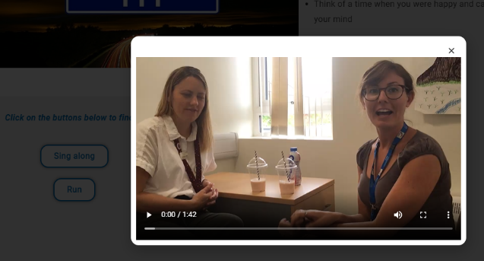
Video
Videos are a great way to engage your audience, rather than walls of text. Videos can be simply added to a page, or also put into a tab or pop up box. The existing portal has some good examples where videos have been used associated with pop-up buttons - scroll down to the “coping with” section of the “Feeling Angry” page for an example and click “Relaxation techniques”
- Videos should be no longer than 5 minutes

