Who should use this template?
Authors who want to provide content on a mental health topic to help young people/adults/people with learning disabilities, or their families/parents/carers should use this template.

Before you use this Template
We recommend that you take a look at the topic content already on the Portal. The content contributors page also provides lots of support for creating content.

How to fill out this Template
Complete the below template along with the Front sheet.

Structuring your content
The template is split into sections to help structure your content: 1) Information 2) Coping with 3) Finding help, and 4) Getting more help.
If you find that these headings do not work for your content, the Custom Topic Template may be more appropriate.
There is also a Topic tile, composed of a word cloud and a few short bullet points, which will be the link on the main page for your content.

Using images, audio and video
Adding media to your content is important in providing a user experience that draws your audience to the content. Media can be from any source but should be royalty free. See the section Guidance on images, audio and video content for further help.

Referencing
It is important that when we use information, images, audio, or video from other sources, that we reference these. So, if content from other places is provided, please add these references as well as the actual content. References should include the website link, author/organisation, and date where applicable.

NSCHT Portal Structured Topic Content
Content Information
Content Title
 | Content Author(s) & Role
 | Do you wish to be acknowledged as the Author on the Portal
 | Yes ☐ |  |  |  |  |  | No ☐
 | Service Applicable To: |  |  |  |  |  |  | Target Audience:
 | CYP | Adult |  |  |  | LD |  | Young people / Adults / People with LD | Family / Parent / Carer
 | ☐ | ☐ |  |  |  | ☐ |  | ☐ | ☐
 | Clinical Content?
 | Yes |  |  |  | No
 | ☐ |  |  |  | ☐

Content Governance
To ensure the content published on the Wellbeing Portal is credible, reliable and of high quality, please ensure the following areas are checked:
Checked | Author | Reviewers
Content tile? | ☐ | ☐
Correctly labelled if containing clinical content? | ☐ | ☐
Clinically/factually correct? | ☐ | ☐
Links work and go to right place? | ☐ | ☐
Spelling/Grammar/Punctuation? | ☐ | ☐

Date
Reviewed By (Colleague / Team / Service):
Directorate Sign-off:
Support - If you require any further clarification on the processes
Portal Topics PortalTopics@combined.nhs.uk

Date
(Digital Team to Complete)
Approved By Clinical Effectiveness Group:
(If clinical content)
Agreed By Quality Committee:
(If clinical content)
Published/ Last reviewed:
To be Reviewed:

A Quick Guide to this Template
= indicates where you need to add text
📷🔉📼 = indicates where you can add images, audio, and videos

Aim
This is a brief statement about what your content will cover.
Please provide the aim of your content

Content Title
Make this a brief as possible (e.g. Alcohol).
Please provide the title for your content.

Topic Tile
The topic tile provides a link to the page with your topic content. Topic tiles are displayed as a word cloud. The word cloud will be autogenerated for you, based upon your topic title. You will have the opportunity to review the word cloud before it is publicly published on the Portal to ensure that all the words used are appropriate.

Structure
To help structure your content, this template is split into different sections. If you find that these headings do not work for your content, the Custom Topic Template may be more appropriate for your content.

Section |  |  | Heading | Description
Section 1 |  |  | Information | An overview of the topic
Section 2 |  |  | Coping with | Advice on dealing with this topic
Section 3 |  |  | Finding help | Links to useful content
Section 4 |  |  | Getting more help | Links to other organisations and services

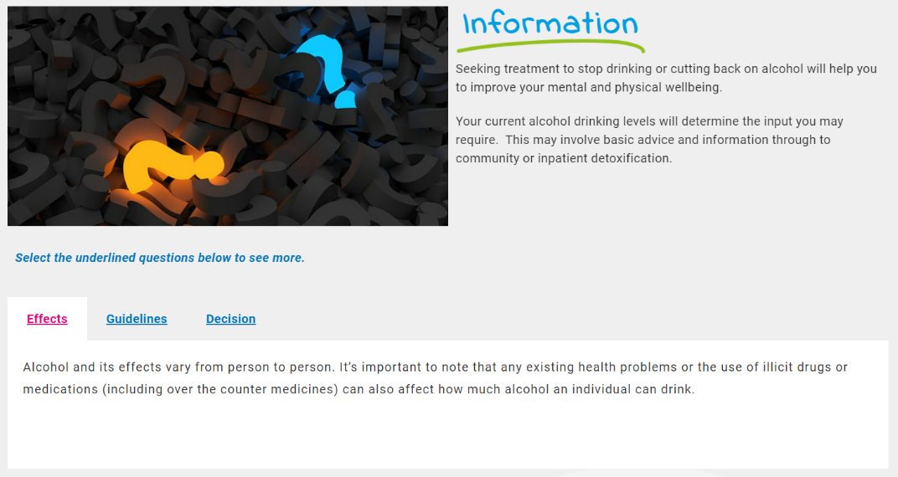
Section 1 – Information
The Information section is where you give an overview of the topic. This section should have:
- An overview of the topic
- What is the positive key message?
- Who / Why / What / How
Try to write in the third person, avoid direct references to “you should …” etc

Information - Content
- Break your text down into sub-sections with headings
- Media can be from any source but should be royalty free
- Remember to provide references if including information, images, audio, or video from other sources. Click here for further guidance
- Complete as many or as few rows as required.

Sub-section heading | Text  Place references to any images, audio, and video where you would like them to appear | Images, audio, & video
 |  | 📷🔉📼

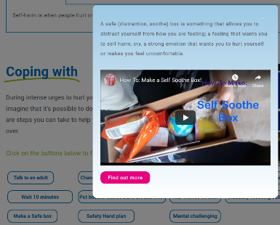
Section 2 – Coping With
In this section provide advice on how young people/adults/people with learning disabilities might deal with this topic. Suggested content includes:
- Suggestions of strategies that can be used; and
- why you would advise this

This section displays multiple pieces of content in a pop-up box when a button is clicked

Coping With - Content
- Break your text down into sub-sections with headings
- Media can be from any source but should be royalty free
- Remember to provide references if including information, images, audio, or video from other sources. Click here for further guidance.
- Complete as many or as few rows as required

Sub-section heading | Pop-Up Text  Place references to any images, audio, and video where you would like them to appear | Images, audio, & video
 |  | 📷🔉📼

Section 3 – Finding Help
This section primarily uses links to content that as person could use to potentially self-manage and improve their own wellbeing. There are 3 types of content in this section:
- Useful documents
- Useful Apps and tools
- Helpful Websites

Under each heading a logo or an image is the main focus.

Finding help - Content
- The portal developers will create the logo or image based on the link you provide

Sub-heading | Link(s) | Optional text to display under the logo
Useful documents
Useful Apps and tools
For mobile apps, add links for both Android and IOS if available
Helpful websites

Section 4 – Getting More Help
This section primarily uses links to other organisations and services that can aid the person. There are 3 types of content in this section.
- Local Services
- National Support Organisations
- Help lines

Under each heading a logo or an image is the main focus.

Getting More Help - Content
- The same organisation can appear in all 3 sub-headings, so add them to as many sections as appropriate
- The portal developers will create the logo or image based on the link you provide

Sub-heading | Link(s) to website(s) | Optional text to display under the logo
Local services
National Support Organisations
Help lines

Guidance on images, audio and video content

Introduction and overview
It is important that the content on the portal comes from experienced professionals, both in mental health services and the community. By providing the information using the advice and format shown in this document, this will allow the portal developers to implement the content much faster.

- The existing content on the portal is a great source of ideas on how content can be presented

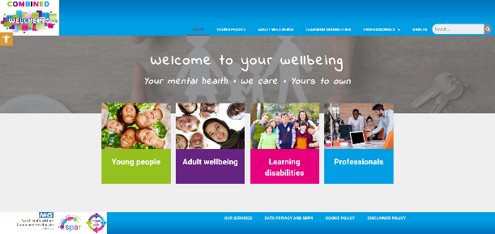
Several pages have already been implemented in the Engagement portal and viewing the site, whilst reading this guide, may be helpful.
- https://combinedwellbeing.org.uk/
- The existing page on self harm for young people is an example of a completed page that uses media well -https://combinedwellbeing.org.uk/topic/self-harm/

Use of media (Photos, graphics, video, audio)
Use of media can be a great way to replace lots of text, with an audio file or a video, Likewise, use of photos with content can help break up the text and make it more engaging.

How to add files
- Go to Insert > Object
- Select Create from File
- Select Browse and choose the file you want to use
- Select Insert
- Choose Display as icon to embed
- Select OK
NB: Add references under each inserted file, where applicable.

Referencing
It is important that when we use information, images, audio, or video from other sources, that we reference these. so if content from other places is provided, please add these references as well as the actual content. References should include the website link, author/organisation, and date where applicable.

All media types
- Media can be from any source, but should be royalty free
- If media is available online, a link to the media is enough, otherwise, please provide the media as a separate file, and provide the file name in this template where requested, so portal developers know where to add them
- Media could be sourced from the community using volunteers and simple use of mobile phones etc (as long as the quality is acceptable)
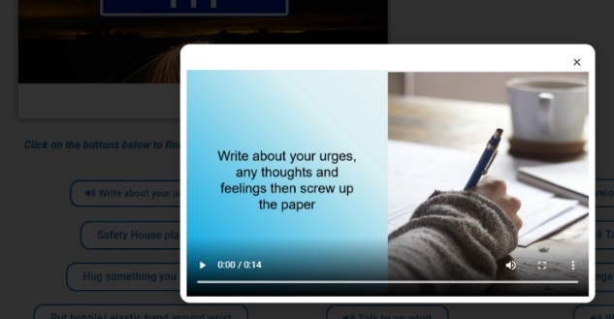

Audio
Use of Audio clips can be a good way to replace text and can be more engaging than reading. The existing portal has some good examples where “soundbites” have been used associated with pop-up buttons – scroll down to the “coping with” section of the “Self harm” page for an example and click “Write about your urges”

Photos/graphics
Where requested in the template above, a suitable photo or link to an online photo should be provided. Whilst the portal developers can attempt to source photos, it is much better to have these provided by an experienced professional in the content
- Some example websites with royalty free images and photos are:
  - https://www.pexels.com/
  - https://pixabay.com/
  - https://blog.snappa.com/free-stock-photos/ - Not a photo site itself, but does list 21 sites
- Photos and graphics should avoid being negative where possible

Logos
Using a logo can be a more engaging way to display the name of a service, and can help to grab the attention of the audience. If a logo is available online, a link to the logo is enough, otherwise, please add the logo as a file. Please ensure you have permission to use any logos.

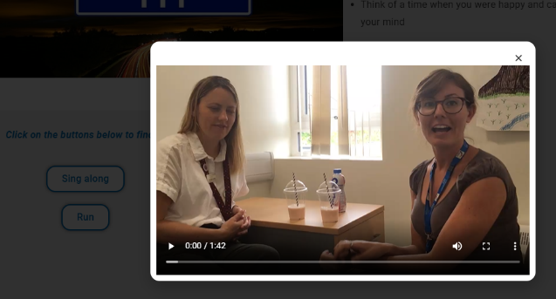
Video
Videos are a great way to engage your audience, rather than walls of text. Videos can be simply added to a page, or also put into a tab or pop up box. The existing portal has some good examples where videos have been used associated with pop-up buttons - scroll down to the “coping with” section of the “Feeling Angry” page for an example and click “Relaxation techniques”
- Videos should be no longer than 5 minutes

