Example

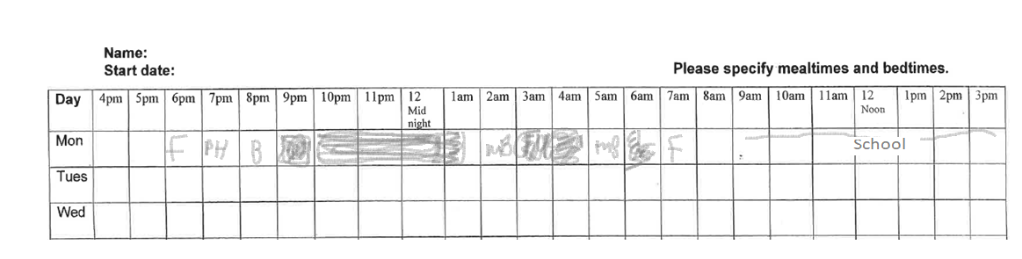

|  |  |
| --- | --- |
|  | 1 Hour |
|  | 45 Minutes |
|  | 30 Minutes |
|  | 15 Minutes |
|  | Food/Mealtimes |
|  | Bed |
|  | Personal Hygiene (baths) |
|  | Mum in bed |